**Hello World RESTful Web Service   
Write a REST service in the spring learn application created earlier, that returns the text "Hello World!!" using Spring Web Framework.**

**Right-click src/main/java/com.cognizant.spring_learn**

**Click New > Package → com.cognizant.spring_learn.controller**

**Right-click the new package → New > Class -> HelloController**

**CODE:-**

**HelloController.java**

**package** com.cognizant.spring_learn.controller;

**import** org.slf4j.Logger;

**import** org.slf4j.LoggerFactory;

**import** org.springframework.web.bind.annotation.GetMapping;

**import** org.springframework.web.bind.annotation.RestController;

@RestController

**public** **class** HelloController {

**private** **static** **final** Logger ***LOGGER*** = LoggerFactory.*getLogger*(HelloController.**class**);

@GetMapping("/hello")

**public** String sayHello() {

***LOGGER***.info("START.....");

String message = "Hello World!!";

***LOGGER***.info("END....");

**return** message;

}

}

**src/main/resources/application.properties**

server.port=8083

spring.application.name=spring-learn

**spring-learn/src/main/java/com/cognizant/spring_learn/SpringLearnApplication.java**

**SpringLearnApplication.java**

**package** com.cognizant.spring_learn;

**import** org.springframework.boot.SpringApplication;

**import** org.springframework.boot.autoconfigure.SpringBootApplication;

@SpringBootApplication

**public** **class** SpringLearnApplication {

**public** **static** **void** main(String[] args) {

SpringApplication.*run*(SpringLearnApplication.**class**, args);

}

}

**OUTPUT:-**

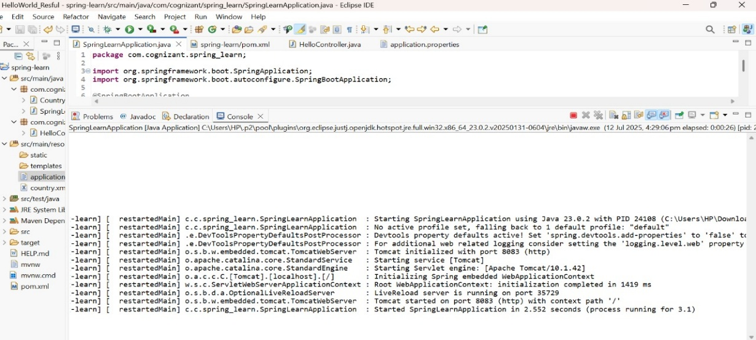

**BROWSER**

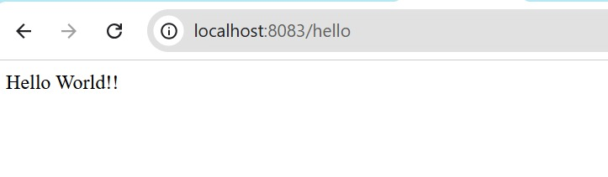

**POSTMAN**

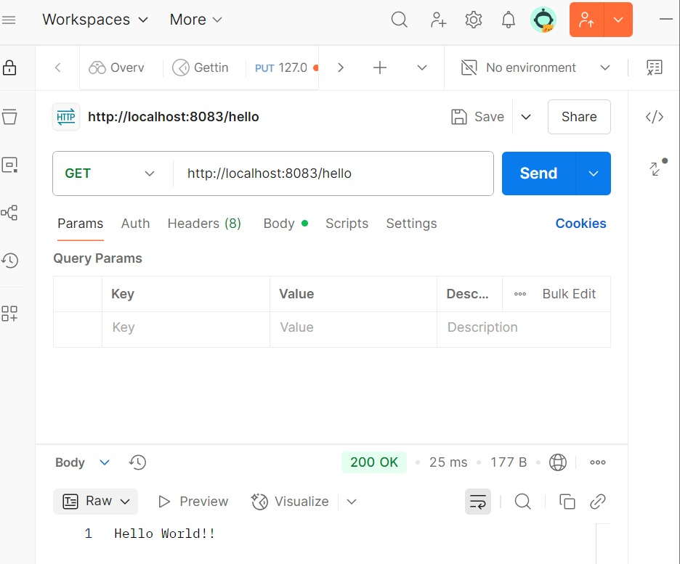

**SME to explain the following aspects:**

**In network tab of developer tools show the HTTP header details received**

Browser– Developer Tools > Network > Headers

🔹 Steps:

Open Chrome and visit: http://localhost:8083/hello

Right-click anywhere → click Inspect or press Ctrl + Shift + I

Go to the Network tab

Refresh the page (F5)

Click the request row (should say /hello)

Click the "Headers" tab on the right

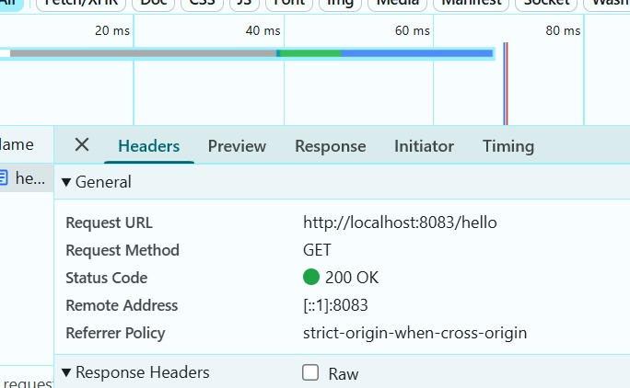

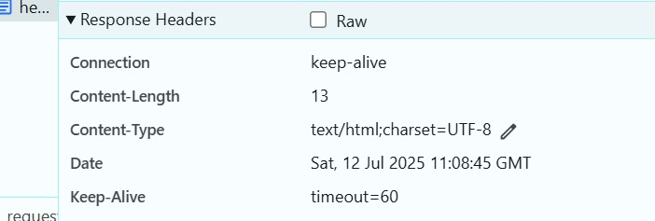

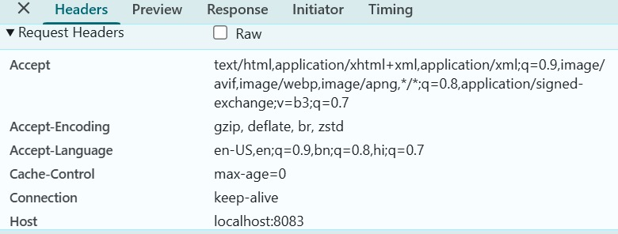

**In postman click on "Headers" tab to view the HTTP header details received**

Open Postman

Enter the URL: http://localhost:8083/hello

Choose GET method

Click Send

